**LAB REPORT – 2**

**Title:**  Measure the frequency response for the different circuits and analyzing the relationship between frequency, voltage and phase.

**Purpose:**

* The purpose of this lab is to become familiar with the oscilloscope and its functions
* Analyze the measurements taken from the oscilloscope for the given circuits and draw the graph to show the relationship between phase and frequency.

**Equipments:**

Prototype Board

Resistor - 100Ω

Capacitor- 0.1µf

Breadboard

Oscilloscope

Connecting wires

Digital Multimeter

**Description:**

**Resistor:** Resistors are the device which are used to control the direction of current flowing to a circuit by applying resistance**.**

**Digital Multimeter:** It’s an electrical tool which is used to measure the current (amp), Voltage (Volt), Resistance (Ohms Ω)

**Breadboard:** It’s a board which helps in building the electrical circuits.

**Capacitor:**  It is a circuit component which is designed to store the electrical charge.

**Oscilloscope:**  It’s an instrument which measures frequency, voltage,phase and shows the wave shape.

**Circuit – 1**

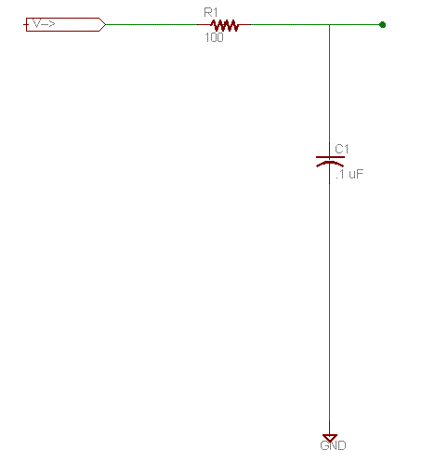

Set up the circuit above on a prototype board, and feed the V_in junction with the function generator output on the power supply.

Today we will use the oscilloscope to measure the voltage and phase at the test point. It is more difficult to get precise numbers from the oscilloscope, but it is easy to see the oscillating nature of the output, and the relationship between input and output voltages.

Set channel one to measure the input voltage, and channel two to measure at the TEST junction. Our digital oscilloscopes can be set up to compute some measurements, and so far as possible, you want to copy numbers down instead of estimating them, so play with that feature.

The frequency produced by our frequency generators may not be exactly as indicated on the input dials, and the voltage tends to change when you change the frequency. So you need to measure the input voltage and input frequency, as well as the output voltage. The output frequency should be the same as the input frequency, but the phase of the output will be different, and since I ask you to graph it, you'll need to measure that also.

Note the value of the input voltage, then record measurements for the output voltage and relative phase for a variety of frequencies: 1,2,4,8,10,20,40,80,100,200,400,800,1000,2000,4000,8000,10000,20000,40000,80000

Usually filter response graphs are presented as a graph of output power versus frequency. Since output power varies as the square of the voltage, you can obtain relative output power in decibels by dB down = 20 log10 (VOUT/VIN). However, to simplify our lives, you can instead graph the ratio VOUT/VIN, as I did above. (The "3 dB down" point is the frequency value for which the value of the ratio is -3, so in a ratio graph the log of the ratio is -0.15, which is a ratio of .707.)

I suggested measuring rapidly increasing frequencies because of the way the output changes. But you won't be able to make much sense of the graph unless you either

1. Use a log scale for the X axis, or
2. Fake the use of a log scale by creating a derived variable defined to be the log of your real X-values, and doing a scatter-plot

You'll be able to use a log-scale if you draw the graph by hand. Just search the internet for log-log graph paper and graph the points. [Here's a sheet of semi-log graph paper I thought would be useful.](http://computersystemsartists.net/spring16/csc7011/assign/lab2/logarithmic-4.pdf)Some graphing programs, like gnu plot, do support log-scale axes. But if you are using Excel, you'll have to play around to get a readable log-scaled graph.

Graph the output phase versus frequency.   
Do a few hand-calculations to see whether the measured values match your understanding of the theory. According to your graph, at what frequency does the circuit seem to be 3 dB down?

**Observation:**

|  |  |  |  |  |  |  |
| --- | --- | --- | --- | --- | --- | --- |
| **Frequency** | **Input frequency(Hz)** | **Output Frequency(Hz)** | **Input Voltage (Volts)** | **Output Voltage(Volts)** | **Phase (Degree)** | **Vout/Vin** |
| **1** | 964300000 | 969900000 | 2.4 | 2.48 | 1.04 | 1.033 |
| **2** | 2.101 | 2.11 | 2.84 | 2.96 | 0.759 | 1.042 |
| **4** | 3.215 | 4 | 3 | 3.12 | -1.45 | 1.040 |
| **8** | 7.73 | 7.81 | 3.08 | 3.12 | -1.4 | 1.013 |
| **10** | 9.91 | 9.95 | 3.08 | 3.2 | -3.6 | 1.039 |
| **20** | 18.59 | 18.6 | 3.12 | 3.12 | -3.58 | 1.000 |
| **40** | 40.34 | 40.54 | 3.12 | 3.2 | 2.4 | 1.026 |
| **80** | 79.38 | 79.95 | 3.12 | 3.2 | -3.4 | 1.026 |
| **100** | 116.3 | 116.1 | 3.12 | 3.2 | -1.4 | 1.026 |
| **200** | 216.2 | 215.4 | 3.12 | 3.12 | -2.36 | 1.000 |
| **400** | 400 | 403.2 | 3.12 | 3.12 | -2.98 | 1.000 |
| **800** | 799.5 | 802.7 | 3.08 | 3.2 | -1.92 | 1.039 |
| **1000** | 1149 | 1140 | 3.08 | 3.12 | -4.45 | 1.013 |
| **2000** | 22240 | 2230 | 3.04 | 3.04 | -11.2 | 1.000 |
| **4000** | 4000 | 4018 | 2.84 | 2.8 | -10.9 | 0.986 |
| **8000** | 7910 | 8000 | 2.4 | 2.24 | -35.3 | 0.933 |
| **10000** | 14020 | 1400 | 2 | 1.68 | -38.9 | 0.840 |
| **20000** | 24110 | 23500 | 1.76 | 1.2 | -20 | 0.682 |
| **40000** | 9480 | 9090 | 1.56 | 0.7 | -21.6 | 0.449 |
| **80000** | 24760 | 25000 | 1.48 | 0.5 | -24.4 | 0.338 |

The measured value of resistor using digital multimeter is **99.2Ω** and the capacitor is **0.104µf.**

We can infer from the above table, that the values of the input frequency and output frequency is almost same.

The above circuit is referred to as a low-pass RC filter circuit since it permits low-frequency signals to pass from the input to the output while attenuating high-frequency signals. At low frequencies, the capacitor has a very large reactance. Consequently, at low frequencies the capacitor is essentially an open circuit resulting in the voltage across the capacitor, Vout, to be essentially equal to the applied voltage,Vin.

At high frequencies, the capacitor has a very small reactance, which essentially short-circuits the output terminals. The voltage at the output will therefore approach zero as the frequency increases.

The analysis of all filters may be simplified by plotting the output/input voltage relationship on a semilogarithmic graph called a Bode plot.

To calculate the power gain Ap = 10log10 Pout/Pin

Voltage gain = 20log10 Vout/Vin

**Calculating the cutoff frequency**

At the cutoff frequency, ωc = 1/RC (fc = 1/2πRC), the gain of the filter is -3 dB. This means that at the cutoff frequency, the circuit will deliver half the power that it would deliver at very low frequencies. At the cutoff frequency, the output voltage will lag the input voltage by 450.

fc  = 1/2πRC = 1/ 2×3.14×99.2Ω × 0.1µf

**fc = 16069.67 Hz**

**Below is the graph between frequency (Hz) and Vout/Vin**

**Below is the graph between Frequency (Hz) and Output Phase (Degree)**

**Below is the graph between Frequency and Voltage Gain (DB)**

From the above graph we can infer that the frequency value at 3dB down is approx. 20kHz.

**Circuit 2:**

Graph the VOUT/VIN ratio versus frequency.

Graph the output phase versus frequency.

Do a few hand-calculations to see whether the measured values match your understanding of the theory.   
According to your graph, at what frequency does the circuit seem to be 3 dB down?

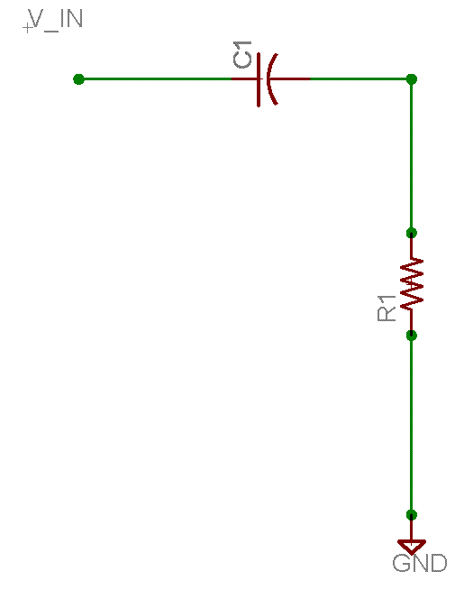

**Observation:**

The measured values from the oscilloscope:

|  |  |  |  |  |  |  |
| --- | --- | --- | --- | --- | --- | --- |
| **Frequency** | **Input Frequency(Hz)** | **Output Frequency(Hz)** | **Input Voltage(Volts)** | **Output Voltage(Volts)** | **Phase** | **Vout/Vin** |
| 1 | 346400 | 320200 | 1.96 | 1.76 | 48.7 | 0.897959 |
| 10 | 12300 | 750000 | 3.12 | 0.2 | -18.97 | 0.064103 |
| 100 | 124.42 | 1300 | 3.16 | 0.24 | -0.002 | 0.075949 |
| 1000 | 1046 | 1220 | 3.16 | 0.4 | 54.1 | 0.126582 |
| 2000 | 2050 | 1939 | 3.12 | 0.56 | 71 | 0.179487 |
| 4000 | 4092 | 4280 | 2.88 | 0.84 | 69.1 | 0.291667 |
| 8000 | 8098 | 8136 | 2.48 | 1.2 | 57.2 | 0.483871 |
| 10000 | 11450 | 11590 | 2.28 | 1.26 | 85.6 | 0.552632 |
| 20000 | 4020 | 3990 | 1.8 | 1.5 | -43.5 | 0.833333 |
| 40000 | 8940 | 10580 | 1.64 | 1.56 | -7.7 | 0.95122 |
| 80000 | 1855 | 1910 | 1.56 | 1.6 | -56.46 | 1.025641 |

**Below is the graph between Frequency (Hz) and Vout/Vin**

**Below is the graph between Frequency (Hz) and Output phase value**

From the above graph we can infer that the frequency value at 3dB down is approx. 5 Hz.

Arnika Vishwakarma (@01367603)

Lab partners – Pravalika , Lina